AIPP LAB 10
Name: SYEDA FARHATH UMAMA
Hall Ticket No.: 2503B05143
Date: 17/11/2025 (Week 4)
___________________________________________________
Completed this Assignment using VS CODE Al Integration.
Task 1:
Provide AI with the following nested conditional code and ask it
to simplify and refactor for readability.
CODE:
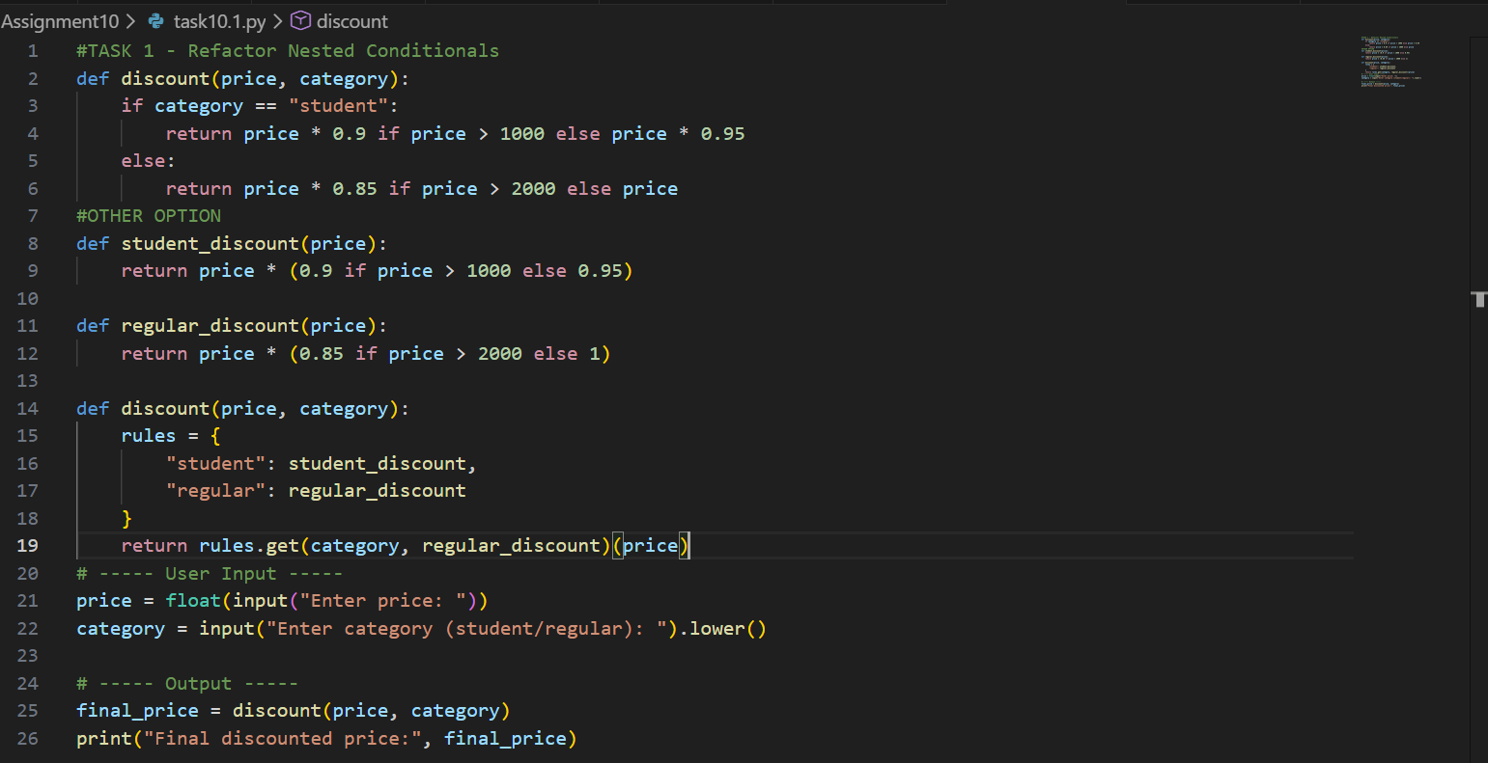

OUTPUT:
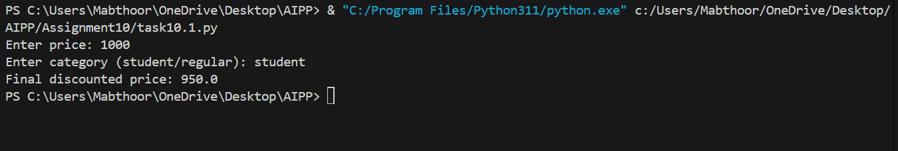

Task 2:
Give AI this messy loop and ask it to refactor and optimize.
CODE:
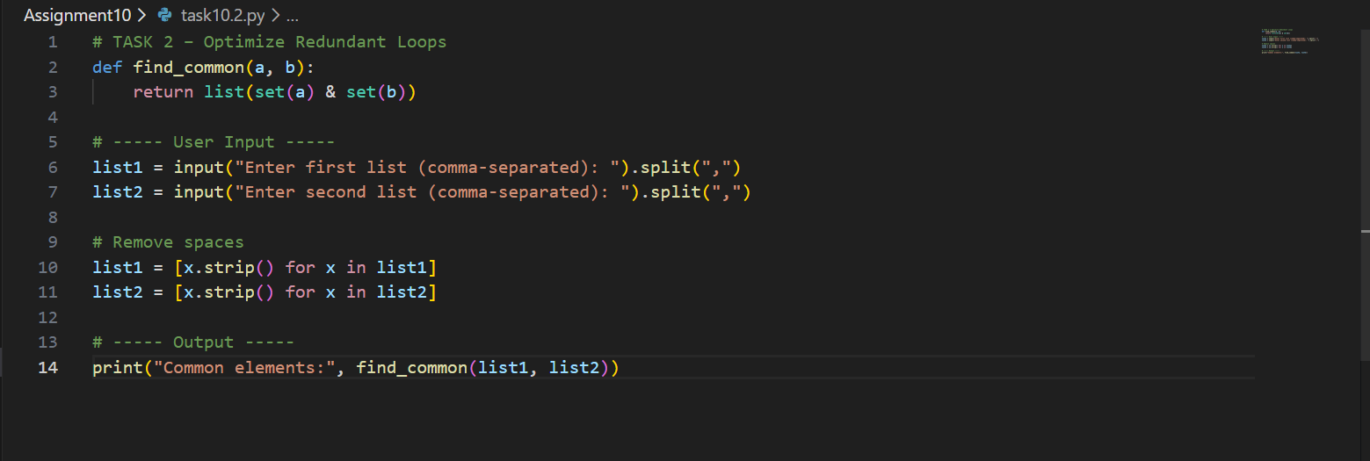
OUTPUT:
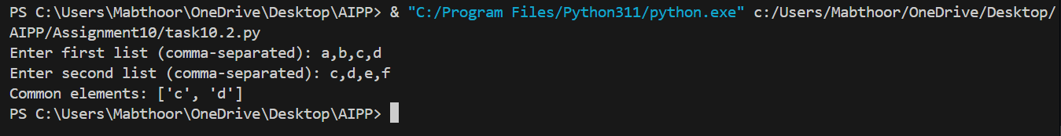

Task 3:
Provide this class with poor readability and ask AI to improve:
• Naming conventions
• Encapsulation
• Readability & maintainability.
CODE:
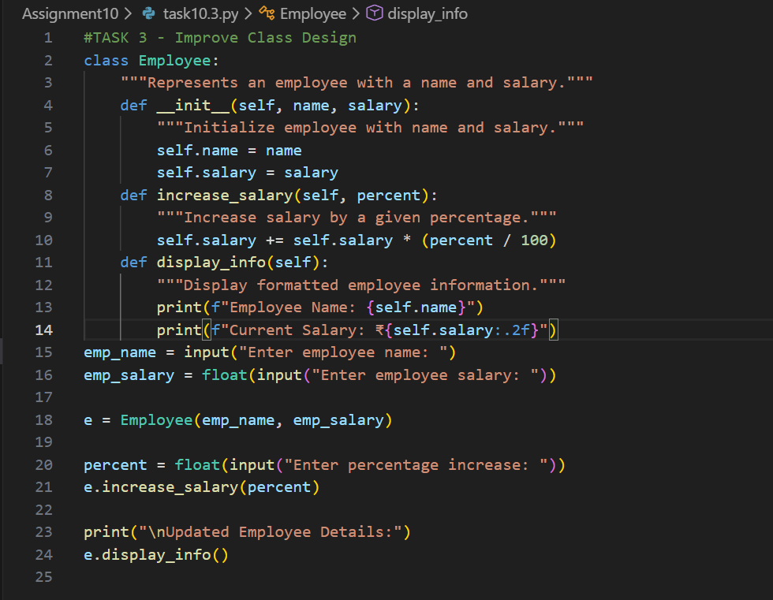
OUTPUT:
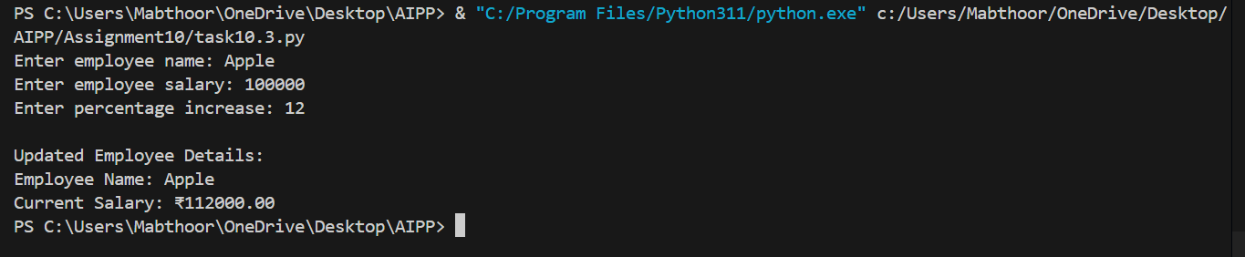
Task 4:
Give AI this long unstructured function and let it modularize into
smaller helper functions.
CODE:
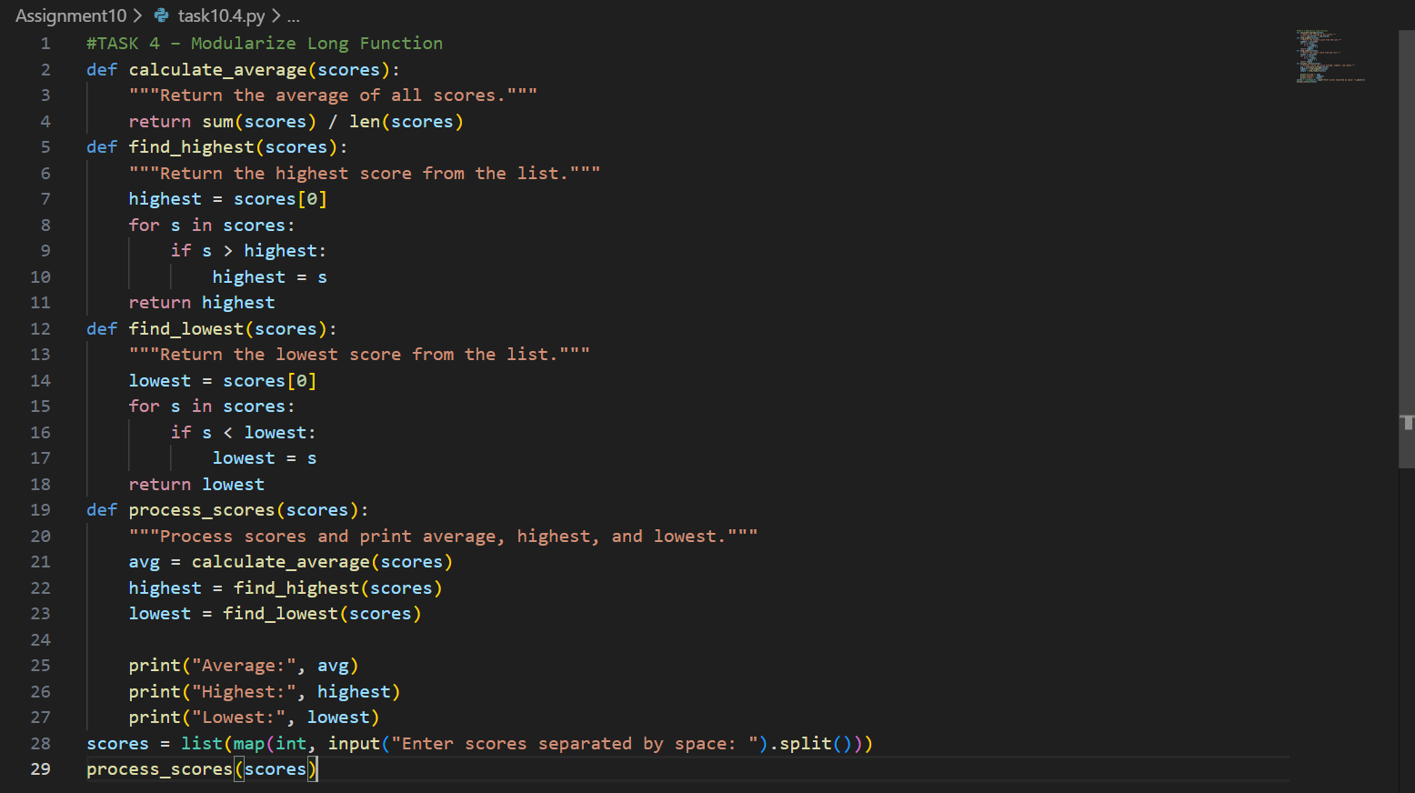
OUTPUT:
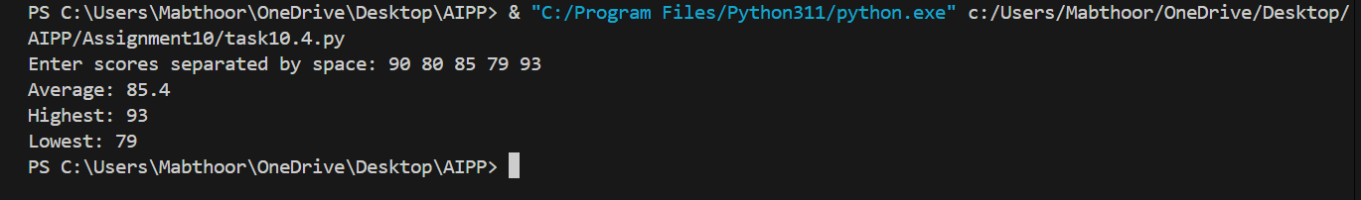
Task 5:
Provide AI with this faulty code and ask it to improve error
handling, naming, and readability.
CODE:
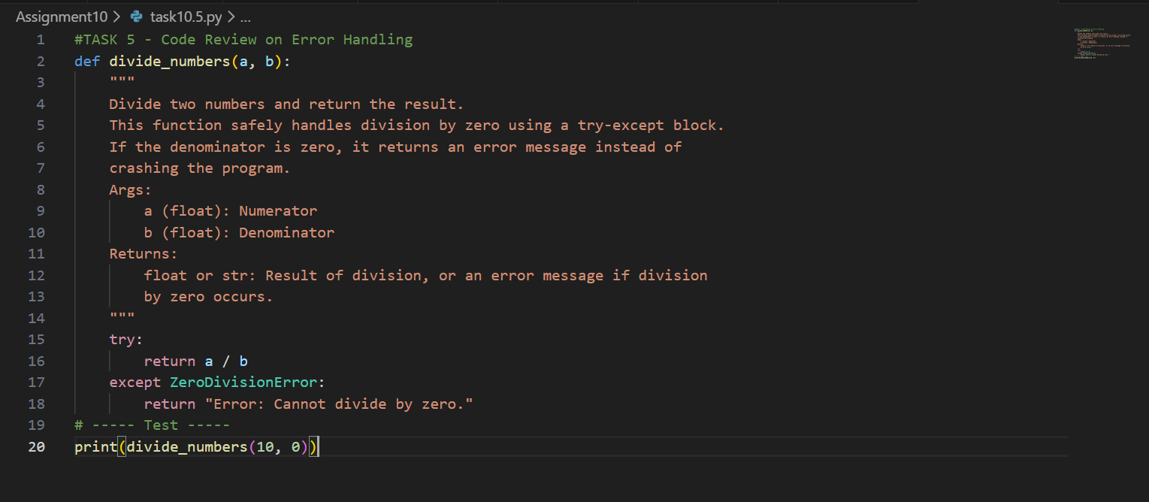
OUTPUT:
Task 6:
Use AI to simplify complex logic.
CODE:
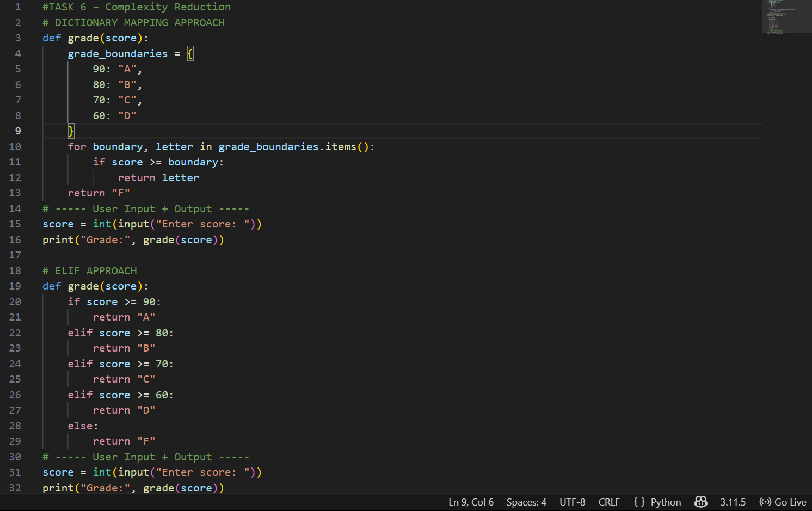
OUTPUT:



